GIRLS

Pre-school, Pre-Primary and Primary
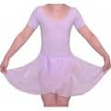
- Lilac short sleeve leotard (Chloe)
- Lilac wraparound georgette skirt
- Pink ballet socks
- Pink leather full sole ballet shoes with pink elastics

Grades 1, 2 and 3

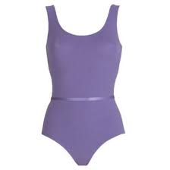
- Lavender sleeveless scoop neck leotard (Aimee) Lavender waist elastic
- Pink ballet socks or tights
- Pink leather full sole ballet shoes with pink elastics
- Black canvas character shoes with pink elastics – Cuban (higher) heel for grade 3 ONLY.
- Black character skirt with ribbons (purples)

Grades 4 and 5

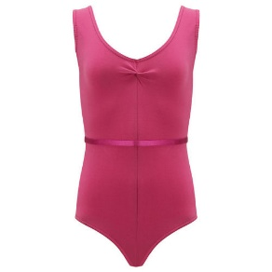
- Mulberry sleeveless ruched neck leotard (Faith)
- Mulberry waist elastic
- Pink ballet tights
- Pink leather split sole ballet shoes with pink elastics
- Black canvas Cuban heel character shoes with pink elastics.
- Black character skirt with ribbons (pinks)

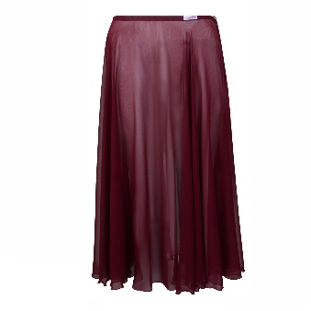
Grades 6, 7 and 8

- Burgundy leotard (any style matte lycra)
- Burgundy chiffon skirt – calf length
- Pink convertible ballet tights
- Pink leather split sole ballet shoes with elastics
- Black canvas Cuban heel character shoes with pink elastics
- Black character skirt with ribbons (pinks)

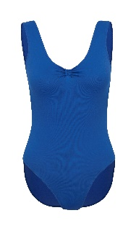
Intermediate Foundation

- Royal Blue “Bethany” Leotard in Meryl Fabric
- Pink convertible ballet tights
- Pink Satin Ballet shoes with ribbons
- Pink Satin Pointe shoes with ribbons

Intermediate

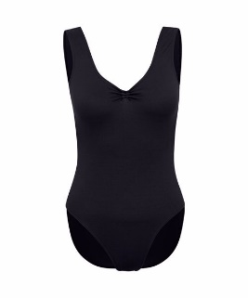
- Black “Bethany” Leotard in Meryl Fabric
- Pink convertible ballet tights
- Pink Satin soft-pointe shoes with ribbons
- Pink Satin Pointe shoes with ribbons

Pointe-Prep

- Any colour or style leotard
- Pink convertible ballet tights
- Pink leather full or split sole ballet shoes with elastics

Girl’s hair must be in a ballet bun for all classes grade 2 and above

BOYS
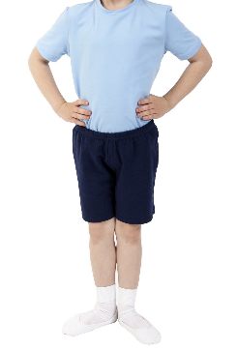
Pre-school, Pre-Primary and Primary

- Light blue t-shirt
- Navy Shorts
- White ballet socks
- White leather ballet shoes with white elastics

Grades 1 – 3

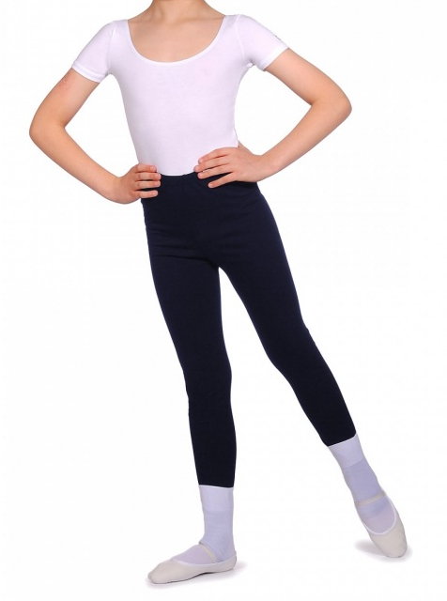
- White short-sleeved leotard or well-fitted t-shirt
- Navy shorts or stirrup tights
- White ballet socks
- White ballet shoes with white elastics
- Black canvas lace-up character shoes

Grade 4 upwards

- White short-sleeved leotard or well-fitted t-shirt
- Navy shorts or stirrup tights
- White ballet socks
- White full or split-sole ballet shoes with white elastics
- Black canvas lace-up character shoes

